

**Digital Tire Management and Monitoring System for Pavara Traders and Services (TireOptiTrack)**

**General Sir John Kotelawala Defence University**

**Faculty of Computing**

Group Member Details

|  |  |  |
| --- | --- | --- |
| Reg.No | Name | Degree |
| 6730 | E. H. M. Diouf | Computer Science |
| D/BSE/23/0015 | T. S. S. Thilakarathna | Software Engineering |
| D/BCE/23/0009 | R. M. J. Jayashan | Computer Engineering |
| D/BCS/23/0018 | B. U. Senanayaka | Computer Science |
| D/BCS/23/0021 | N. T. P. G. B. Upethra | Computer Science |

Supervisor :　Mrs. SCMDS Sirisuriya

February 2024

Abstract

The upcoming "Digital Tire Management and Monitoring System," known as TireOptiTrack, is set to modernize how Pavara Traders and Services handles tires for their harbor vehicles and machinery. Instead of the current manual logbook approach, this new web application, going to create with the React framework, provides a user-friendly solution to tackle issues like mistakes in data entry, time-consuming processes, and difficulties in data analysis. The system includes a strong database to store a variety of tire information such as serial numbers, tread depth, pressure, brand, and more. With separate logins for data entry officers and viewers, the former can efficiently input and update tire data, receive timely alerts, and manage inspection schedules. At the same time, authorized viewers can access detailed insights for better decision-making. The application features driver alerts, useful reporting tools, and a responsive dashboard, ensuring data security and easy mobile use. By simplifying workflows, this system not only overcomes manual entry challenges and boosts analysis efficiency but also sets the stage for more precise tire management and improved overall efficiency at Pavara Traders and Services.

Table of Contents

Group Member Details iii

Abstract iiii

Table of Contents iv

List of Figures v

Chapter 1 Introduction 1

1.1 Background of the Studies 1

1.2 Problem Identification 2

1.3 Objectives 3

Chapter 2 Literature Review 4

Chapter 3 Proposed Methodology 6

3.1 Flow Diagram 6

3.2 Functional Requirements and Non-Functional Requirements 6

3.3 Proposed Testing and Evaluation Method 8

Chapter 4 Time Frame 10

Chapter 5 Budget 11

Chapter 6 Conclusion 12

Chapter 7 References 13

List of Figures

Figure 1: Manual Logbook 1

Figure 2: Current Data Entry Process 1

Figure 3: Gantt Chart 10

# Introduction

# 

## Background of the Studies

The background of the study is framed by Pavara Traders and Services' significant role in harbor machinery maintenance, notably at the South Asia Gateway Terminals (SAGT) in the Port of Colombo. Recognizing the critical importance of tire management in ensuring the operational efficiency and safety of harbor vehicles and machinery, the company currently relies on a manual logbook system.

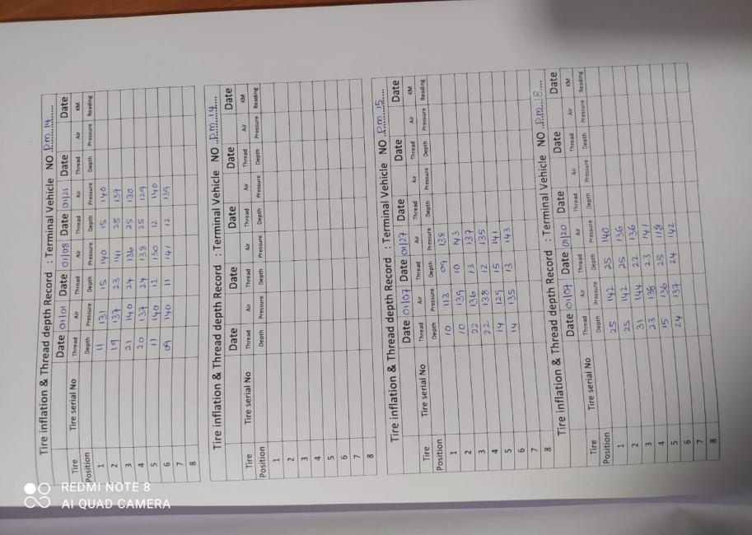

Figure 2: Current Data Entry Process

Figure 1: Manual Logbook

However, this existing manual system has revealed inefficiencies, prompting the need for a modernized tire management system. The limitations of the manual logbook, such as data entry errors, time inefficiency, and restricted data analysis capabilities, have become apparent. Given the demanding nature of harbor machinery maintenance and the strategic location of the company within the Port of Colombo, a more streamlined and technologically advanced solution is imperative.

Hence, the background of the study emphasizes the contextual significance of Pavara Traders and Services in the harbor machinery maintenance sector, highlighting the challenges posed by the current manual logbook system. The study aims to address these challenges through the proposed "Digital Tire Management and Monitoring System" (TireOptiTrack), positioning itself as a crucial step towards optimizing tire management processes in a dynamic and vital operational environment.

## Problem Identification

1. **Data Entry Errors**: The manual recording of tire-related information is prone to errors, leading to inaccuracies in crucial details such as tire pressure, tread depth gauge readings, and kilometers traveled and etc.
2. **Time Inefficiency**: The manual logbook system is time-consuming, requiring significant effort and resources for data entry, retrieval, and analysis. This inefficiency hampers the overall operational efficiency of tire management processes.
3. **Limited Data Analysis Capabilities**: Retrieving historical tire data for analysis is a cumbersome task due to the manual nature of the logbook system. This limitation hinders the ability to derive meaningful insights and make informed decisions regarding tire maintenance.
4. **Inability to Make Informed Decisions**: The lack of real-time monitoring and constrained data analysis capabilities limits the company's ability to make timely and informed decisions about tire replacements, maintenance schedules, and overall operational strategies.
5. **Lack of Real-time Monitoring**: The absence of real-time monitoring poses a risk of overlooking critical tire issues, as the manual system relies on periodic checks rather than continuous, instantaneous data updates.
6. **Dependency on Paper-Based Records**: The reliance on physical logbooks introduces the potential for data loss or damage, further complicating the tire management process.

## Objectives

1. **Ensure Streamlined Workflows**: Develop systematic workflows within the web application to address the current time inefficiencies associated with manual data entry, retrieval, and analysis. Streamline processes to enhance overall operational efficiency in tire management.
2. **Increase Efficient Data Storing**: Create a user-friendly web application that facilitates efficient and accurate manual entry of tire-related information, including tire pressure, tread depth, serial numbers, brand, date of measurement, and kilometers traveled.
3. **Implement Distinct User Portals**: Design two distinct login interfaces—one for data entry officers responsible for manually inputting and managing tire data, and another for authorized viewers, including personnel and drivers, to access real-time information and make informed decisions.
4. **Enable Real-time Monitoring and Alerts**: Implement a real-time monitoring system that provides instant updates on tire conditions. Introduce an alert mechanism to notify drivers and authorized personnel of upcoming tire checks, promoting timely maintenance.
5. **Design User-Friendly Interfaces**: Design user interfaces that are intuitive and user-friendly, promoting ease of use for both data entry officers and authorized viewers. Ensure mobile responsiveness for accessibility across various devices.
6. **Enhance Security Measures**: Prioritize security measures to ensure data integrity and prevent unauthorized access. Implement secure authentication mechanisms for both data entry officers and authorized viewers.
7. **Efficient Data Analysis**: Develop a robust database and reporting modules to facilitate efficient manual data analysis. Enable data entry officers and authorized viewers to access summarized and detailed tire information for enhanced decision-making.

# Literature Review

*Literature Review of Macksons Holdings in their manual transport management system and proposes the development of a Fleet Management System*

Both projects acknowledge the challenges inherent in manual systems used for managing vehicle information, driver details, allocation decisions, reporting, and the overall organization of transportation processes. They recognize the inefficiencies of relying on manual methods. The objectives of both projects align in the pursuit of introducing an optimal method for handling daily transport duties. This includes eliminating paperwork and manual processes, increasing overall productivity and efficiency, and facilitating quick decision-making by providing timely information.

The proposed scope of both projects encompasses similar functionalities, such as the storage of vehicle and driver information, effective management of delivery expenses, handling of driver payments, maintenance of vehicle-related expenses, and the generation of various reports to aid in decision-making. The analysis chapters in both projects follow a similar structure, incorporating an analysis phase that considers the drawbacks of the existing manual systems and the motivations for proposing a new digital solution.

The organizational background varies between the two projects, as they cater to different companies operating in distinct industries. Pavara Traders and Services focus on harbor vehicle maintenance, while Macksons Holdings is a diversified conglomerate involved in manufacturing, retailing, and other sectors. The scope focus diverges as well. While both projects involve fleet management, Pavara Traders and Services' project places a specific emphasis on tire-related data and monitoring, distinguishing it from a more generalized fleet management approach. Implementation details, tools, and technologies may differ based on the specific needs and preferences of each company. The projects may take distinct approaches in utilizing technology to address unique challenges.

In conclusion, both projects share common ground in recognizing and addressing challenges associated with manual transport management systems. The literature review emphasizes the importance of tailoring solutions to the unique requirements of each organization and highlights the limitations of generic off-the-shelf software. TireOptiTrack is well-aligned with industry needs, showcasing a tailored approach to overcome identified challenges.

# Proposed Methodology

Agile Methodology will be used thorough-out the project.

## Flow Diagram

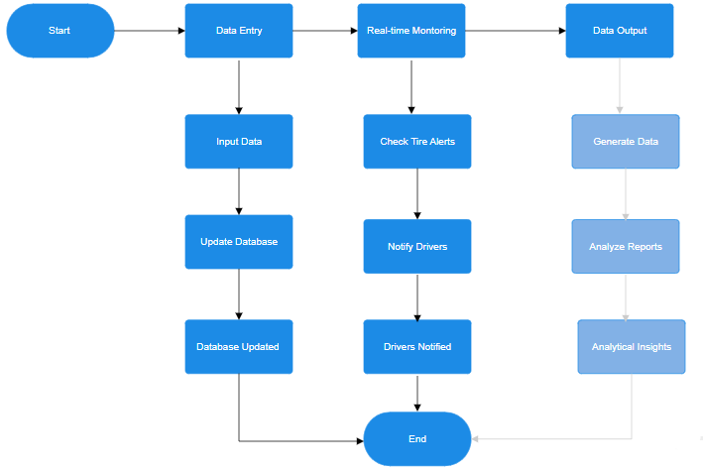

Figure 3: Planning Flow Diagram of the System

## Functional Requirements and Non-Functional Requirements

Functional Requirements:

1. User Authentication and Authorization:

* The system should provide secure login portals for two user roles: Data Entry Officers and Viewers.
* Users must be authenticated before accessing the system.
* Data Entry Officers should have the capability to input, update, and manage tire-related information.

1. Data Entry and Management:

* The system should allow Data Entry Officers to input crucial tire-related information.
* Data Entry Officers should be able to update and modify tire data as needed
* The system must include validation checks to ensure data accuracy.

1. Viewing Portal:

* Authorized Viewers should have access to real-time tire information for analysis and decision-making.
* Viewers should be able to retrieve summarized and detailed tire data for individual vehicles.

1. Alert System:

* Drivers should receive alerts every three weeks to check and update tire information.
* Data Entry Officers should receive alerts for upcoming tire checks and a list of vehicles due for inspection every three weeks.

1. Reporting Modules:

* The system should include reporting modules for detailed analysis of tire-related data.
* Reports may include trends, patterns, and insights into overall tire health.

1. Responsive Dashboard:

* A responsive dashboard should be provided for quick insights into the overall status of tires.
* The dashboard should present key metrics and visualizations for easy interpretation.

1. Database Management:

* The system must include a robust database to store and organize the extensive dataset associated with tire management.
* Data should be structured logically for efficient retrieval and analysis.

1. Report Generation:

* The system should enable users to generate and export detailed reports based on the visualizations created.
* Customizable report templates to accommodate various reporting needs.

1. Interactive Visualizations:

* Interactive elements, such as clickable data points or filters, should be incorporated to allow users to explore data dynamically.
* Drill-down capabilities for detailed insights into specific aspects of tire performance and maintenance.

Non-Functional Requirements:

1. Security:

* The system must prioritize data security, ensuring that only authorized personnel can access sensitive information.
* Secure authentication mechanisms should be in place.
* Ensure secure and encrypted data transfer between the TireOptiTrack system and Power BI.

1. Usability:

* User interfaces for both Data Entry Officers and Viewers should be user-friendly.
* The system should provide an intuitive and efficient user experience.

1. Scalability:

* The system should be scalable to accommodate the growing dataset and potential future expansion of the fleet.
* Power BI integration will handle larger datasets without compromising performance.

1. Performance:

* The system should perform efficiently, providing real-time access to data without significant delays.
* Response times for data entry and retrieval should be optimized.

1. Reliability:

* The system must be reliable, minimizing downtime and ensuring continuous availability.
* Ensure the reliability of Power BI connections to prevent data loss or inconsistencies.

1. Compatibility:

* The web application should be compatible with various devices and browsers for flexibility in usage.

1. Mobile Responsiveness:

* The user interface should be responsive, allowing users to access the system from mobile devices.

1. Data Integrity:

* Measures should be in place to ensure the integrity of the tire-related data stored in the database.

## Proposed Testing and Evaluation Method

Testing

In testing process for TireOptiTrack will be a comprehensive and systematic approach, encompassing **unit testing** to verify individual module functionality, then by **integration testing** to ensure seamless interaction between components, and **user acceptance testing** with a focus on aligning the system with end-user requirements. **Performance, security, compatibility, usability,** and **scalability testing** will address aspects such as system responsiveness, data protection, cross-device functionality, user experience, and the ability to handle growing datasets. These tests will be conducted iteratively, incorporating user feedback and continuous improvement, with the ultimate goal of delivering a robust, user-friendly, and high-performing digital tire management system for Pavara Traders and Services.

Evaluation

The evaluation criteria will revolve around the reliability of tire data, user satisfaction with system functionalities, performance metrics such as response times and system scalability, and the effectiveness of security measures in safeguarding tire-related information. These criteria collectively aim to ensure the successful development and implementation of the TireOptiTrack system.

# Time Frame

Figure 3: Gantt Chart

# Budget

1. **Licensing Fees**

Investments in software licenses are crucial for the development and functionality of the Tire Management Software. This includes licenses for essential development tools, databases, and any third-party components that enhance the application's capabilities. Accurate budgeting for licensing fees ensures legal compliance and optimal use of software resources.

1. **Infrastructure Setup**

Creating the right technological environment is a fundamental aspect of the project. Costs associated with infrastructure setup cover the establishment of servers, deployment tools, and the necessary hardware and software framework. A robust infrastructure is the backbone of the application, ensuring stability, reliability, and scalability.

1. **Cloud Server Expenses**

Utilizing cloud servers offers flexibility, scalability, and accessibility. Cloud server expenses encompass monthly or annual payments, considering factors such as storage, bandwidth, and computing resources. This approach allows Pavara Traders and Services to efficiently manage data, provide seamless user experiences, and adapt to changing operational demands.

1. **Miscellaneous Expenses**

In any development project, unforeseen or miscellaneous expenses may arise. These could include unexpected software requirements, additional training needs, or unanticipated challenges during the development process. Allocating a budget for miscellaneous expenses ensures flexibility in adapting to evolving project dynamics without compromising quality.

These identified costs collectively form a comprehensive financial plan for the development and implementation of the Tire Management Software. Careful consideration and allocation of resources in these categories contribute to the success and sustainability of the project.

# Conclusion

1. **Proposal Summary:**

This document presents a plan for developing a user-friendly Tire Management Software tailored for Pavara Traders and Services, accessible through the web.

1. **Purpose:**

The software targets the challenges of manual tire data handling, with the goal of improving accuracy and efficiency in tire management processes.

1. **Digital Transformation:**

The move to a digital platform offers benefits such as enhanced accessibility, real-time monitoring, and streamlined data management.

1. **Benefits:**

Anticipated advantages include improved tire management efficiency, operational effectiveness, and a shift towards innovative practices.

1. **Game-Changer:**

The web-based application is envisioned as a transformative tool, poised to revolutionize how Pavara manages tires and positions itself within the industry.

1. **Current Issues Resolution:**

Beyond resolving current challenges, the digital solution positions Pavara as an industry innovator in effective tire management within the maintenance and repair sector.

|  |  |  |  |  |  |  |  |  |
| --- | --- | --- | --- | --- | --- | --- | --- | --- |
| References  |  |  | | --- | --- | | [1] | Anhar, M.A.M. (1970) *Web Based Fleet Management System for Macksons Paint Lanka (pvt) ltd*, *Digital Library of University of Colombo School of Computing: Home*. Available at: https://dl.ucsc.cmb.ac.lk/jspui/handle/123456789/4078. | | [2] | “Haltec Tire Management System About the Haltec Tire Management System.” Accessed: Feb. 05, 2024. [Online]. Available: https://www.haltec.com/pc/catalog/PDF%27s/Haltec%20Tire%20Management%20System.pdf  ‌ | | [3] | “GUIDE TO TYRE MANAGEMENT ON HEAVY VEHICLES.” Available: https://btmauk.com/wp-content/uploads/2020/04/October-2016-CV-TyreManagement-LINKS-270916.pdf  ‌ | |  |  | |
|  |
|  |
|  |